Piece of the Py - Group Project 1

What are the historical trends in housing prices?
- As apparent by the chart, the Northeast and West regions have significantly different average home prices.
- The South and Midwest homes are the same on average.
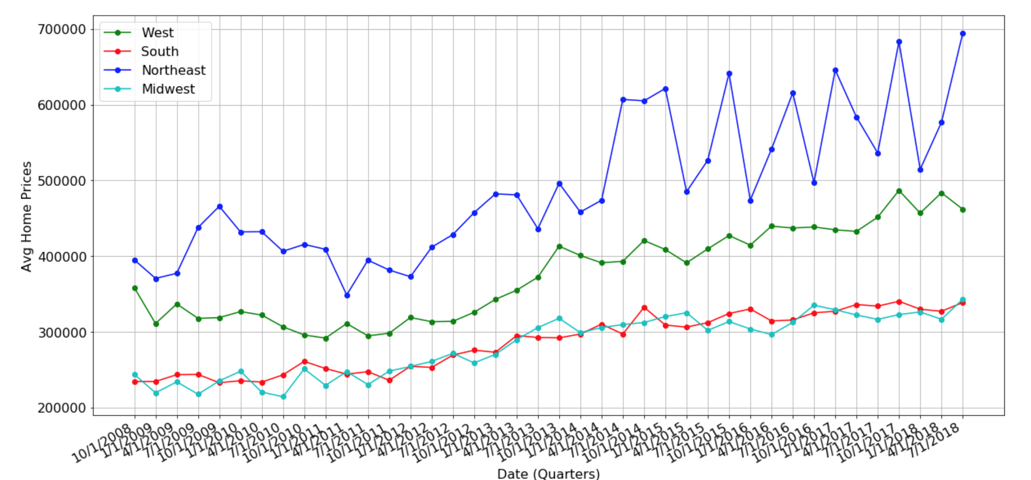

What are the potential indicators of housing prices?
- While fed funds rate has a strong correlation to housing prices, unemployment seemed to have an inverse correlation to housing prices, and income and stock market movement has little or no correlation to housing prices, it is unclear if any one of these inputs directly impacts the price of housing or indicates where prices will move.

How well do the indicators correlate and indicate the direction of prices?
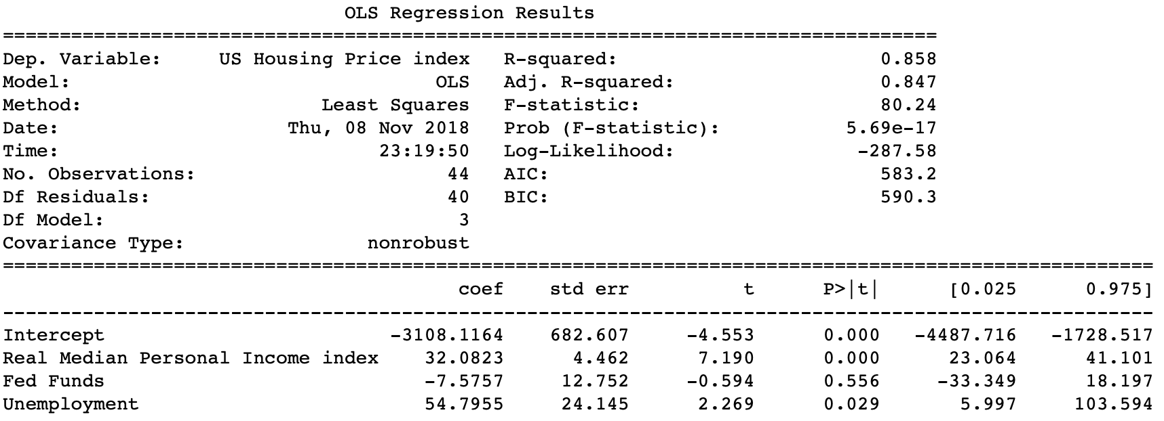
- R2 value increased to 85.8% suggesting a much stronger model than the prior analysis.
- However, this model indicates that the Fed Funds Rate is not significant in housing prices.
- Further addition of inputs would be required to make a satisfactory model for housing prices

What will the homebuyers within our team do with this knowledge of their upcoming home purchases?
- Due to the variability in the NorthEast housing market as well as the fact that currently interest rates seems to be driving the decrease in housing prices, the 2 members of the team that were looking to purchase in the near future had different results.
- The first is continuing their search trying to purchase before the Spring market while the other has decided to hold off and not purchase at this time.

